Лабораторная работа №4
Программирование сокетов

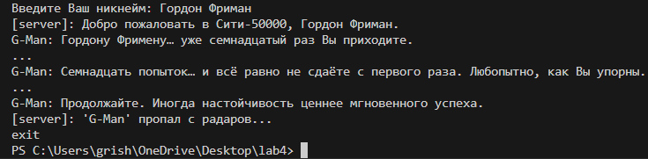

Для IntelliJ IDEA нужно было включить эмуляцию реального терминала в VM Options: «-Djdk.console=jdk.internal.le».

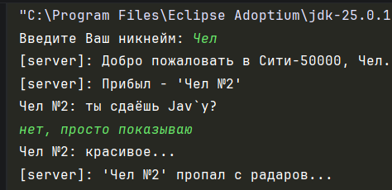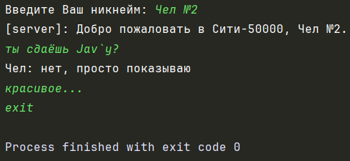

Собрал артефакты клиента и сервера, запустил через батник:
@echo off
java -jar "client/server.jar"
pause

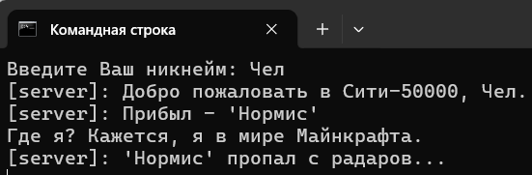

common.model.Message.java:
package com.common.model;
import java.io.Serializable;
import java.time.LocalDateTime;
import lombok.AllArgsConstructor;
import lombok.Data;
@Data
@AllArgsConstructor
public class Message implements Serializable {
private String username;
private String text;
private LocalDateTime time;
}

common.util.PropertiesHandler.java:
package com.common.util;

import java.util.Properties;

public class PropertiesHandler {
private PropertiesHandler() {
}
public static Properties load(String name) {
var p = new Properties();
try (var is = PropertiesHandler.class.getClassLoader().getResourceAsStream(name)) {
p.load(is);
} catch (Exception e) {
LoggerHandler.error(e);
}
return p;
}
}

common.util.LoggerHandler.java:
package com.common.util;

import lombok.extern.slf4j.Slf4j;

@Slf4j
public class LoggerHandler {
private LoggerHandler() {
}
public static void error(Exception e) {
log.error("{}", e.toString());
}
public static void info(String message) {
log.info("{}", message);
}
public static void printMessage(String message) {
System.out.println(message);
log.info("{}", message);
}
}

server.ServerApplication.java
package com.example;

import com.example.config.ServerConfig;
import com.example.net.ChatServer;

public class ServerApplication {
public static void main(String[] args) {
var config = ServerConfig.load();
new ChatServer(config).start();
}
}

server.resources.server.properties
port=50000

server.config.ServerConfig.java
package com.example.config;

import com.common.util.PropertiesHandler;
import lombok.Getter;
import lombok.RequiredArgsConstructor;

@Getter
@RequiredArgsConstructor
public class ServerConfig {
private final int port;

public static ServerConfig load() {
var p = PropertiesHandler.load("server.properties");
return new ServerConfig(Integer.parseInt(p.getProperty("port")));
}
}

server.net.ChatServer.java
package com.example.net;
import java.io.IOException;
import java.net.ServerSocket;
import java.net.SocketException;
import java.time.LocalDateTime;
import java.util.Map;
import java.util.Scanner;
import java.util.concurrent.ConcurrentHashMap;
import java.util.concurrent.ExecutorService;
import java.util.concurrent.Executors;
import lombok.RequiredArgsConstructor;
import com.common.model.Message;
import com.common.util.LoggerHandler;
import com.example.config.ServerConfig;

@RequiredArgsConstructor
public class ChatServer {
private final ServerConfig config;
private final ExecutorService pool = Executors.newCachedThreadPool();
private final Map<String, ClientHandler> clients = new ConcurrentHashMap<>();
private static final String SERVER_NAME = "[server]";
private volatile boolean running = true;

public void start() {
try (var serverSocket = new ServerSocket(config.getPort())) {

LoggerHandler.info("Сервер запущен на порту: " + config.getPort());
startConsoleListener(serverSocket);

while (running) {
var socket = serverSocket.accept();
var handler = new ClientHandler(socket, this);

var username = handler.getUsername();
if (username == null || username.isEmpty()) {
handler.close();
continue;
}

clients.put(username, handler);
pool.submit(handler);

broadcast(new Message(SERVER_NAME, "Прибыл - '" + username + "'", LocalDateTime.now()), handler);
handler.send(
new Message(SERVER_NAME,
"Добро пожаловать в Сити-" + config.getPort() + ", " + username + ".",
LocalDateTime.now()));
}

} catch (SocketException e) {
LoggerHandler.info("Сервер завершает работу по причине: " + e.toString());
} catch (IOException | ClassNotFoundException e) {
LoggerHandler.error(e);
} finally {
shutdown();
}
}

public void broadcast(Message message, ClientHandler sender) {
clients.values().stream()
.filter(h -> h != sender)
.forEach(h -> h.send(message));
}

public void remove(String username, ClientHandler sender) {
if (username != null) {
clients.remove(username);
var msg = new Message(SERVER_NAME, "'" + username + "' пропал с радаров...", LocalDateTime.now());
broadcast(msg, sender);
}
}

private void shutdown() {
running = false;
clients.values().forEach(ClientHandler::close);
pool.shutdownNow();
}

private void startConsoleListener(ServerSocket serverSocket) {
new Thread(() -> {
try (var scanner = new Scanner(System.in)) {
while (running) {
if (scanner.nextLine().equalsIgnoreCase("exit")) {
running = false;
try {
if (!serverSocket.isClosed()) {
serverSocket.close();
}
} catch (IOException e) {
LoggerHandler.error(e);
}
}
}
}
}, "ConsoleListener").start();
}
}

server.net.ClientHandler.java
package com.example.net;
import java.io.IOException;
import java.io.ObjectInputStream;
import java.io.ObjectOutputStream;
import java.net.Socket;
import com.common.model.Message;
import com.common.util.LoggerHandler;
import lombok.Getter;

public class ClientHandler implements Runnable {
private final Socket socket;
private final ChatServer server;
private final ObjectOutputStream out;
private final ObjectInputStream in;

@Getter
private String username;

public ClientHandler(Socket socket, ChatServer server) throws IOException, ClassNotFoundException {
this.socket = socket;
this.server = server;
out = new ObjectOutputStream(this.socket.getOutputStream());
out.flush();
in = new ObjectInputStream(this.socket.getInputStream());
username = (String) in.readObject();
}

@Override
public void run() {
try (socket;) {
while (true) {
var msg = (Message) in.readObject();
if (msg == null || msg.getText() == null || "exit".equals(msg.getText())) {
break;
}
server.broadcast(msg, this);
}
} catch (IOException | ClassNotFoundException e) {
LoggerHandler.error(e);
} finally {
server.remove(username, this);
close();
}
}

public synchronized void send(Message message) {
try {
out.writeObject(message);
out.flush();
} catch (Exception e) {
LoggerHandler.error(e);
}
}

public void close() {
try {
if (!socket.isClosed()) {
socket.close();
}
} catch (IOException e) {
LoggerHandler.error(e);
}
}
}

client.ClientApplication.java
package com.client;
import com.client.config.ClientConfig;
import com.client.net.ChatClient;
import com.common.util.LoggerHandler;

public class ClientApplication {
public static void main(String[] args) {
var console = System.console();
if (console == null) {
LoggerHandler.printMessage("Консольный режим недоступен...");
return;
}

var username = "";
while (true) {
var input = console.readLine("Введите Ваш никнейм: ");
if (!input.isBlank() && input.trim().length() >= 3) {
username = input;
break;
}
LoggerHandler.printMessage("Никнейм не должен быть пустым и должен быть длиннее 3 символов!");
}

var config = ClientConfig.load();
new ChatClient(config, username).start();
}
}

client.resources.client.properties
host=localhost
port=50000

client.config.ClientConfig.java
package com.client.config;

import com.common.util.PropertiesHandler;
import lombok.Getter;
import lombok.RequiredArgsConstructor;

@Getter
@RequiredArgsConstructor
public class ClientConfig {
private final String host;
private final int port;

public static ClientConfig load() {
var p = PropertiesHandler.load("client.properties");
return new ClientConfig(
p.getProperty("host"),
Integer.parseInt(p.getProperty("port"))
);
}
}

client.net.ChatClient.java
package com.client.net;

import java.io.EOFException;
import java.io.IOException;
import java.io.ObjectInputStream;
import java.io.ObjectOutputStream;
import java.net.Socket;

import com.client.config.ClientConfig;
import com.common.util.LoggerHandler;

import lombok.Getter;
import lombok.RequiredArgsConstructor;
import lombok.Setter;

@RequiredArgsConstructor
public class ChatClient implements Runnable {
private final ClientConfig config;
private final String username;

@Getter
@Setter
private volatile boolean running = true;

public void start() {
new Thread(this).start();
}

public void shutdown() {
running = false;
}

@Override
public void run() {
try (var socket = new Socket(config.getHost(), config.getPort());
var out = new ObjectOutputStream(socket.getOutputStream());
var in = new ObjectInputStream(socket.getInputStream())) {

out.writeObject(username);
out.flush();

var receiver = new Receiver(in, this);
var receiverThread = new Thread(receiver);
receiverThread.start();

var sender = new Sender(username, out, this);
var senderThread = new Thread(sender);
senderThread.start();

senderThread.join();
receiverThread.join();

LoggerHandler.info(username + " закончил общение.");
} catch (EOFException e) {
LoggerHandler.info(e.toString());
} catch (IOException | InterruptedException e) {
LoggerHandler.error(e);
Thread.currentThread().interrupt();
}
}
}

client.net.Receiver.java
package com.client.net;

import java.io.ObjectInputStream;
import java.net.SocketException;

import com.common.model.Message;
import com.common.util.LoggerHandler;
import lombok.RequiredArgsConstructor;

@RequiredArgsConstructor
public class Receiver implements Runnable {
private final ObjectInputStream in;
private final ChatClient client;

@Override
public void run() {
try {
while (client.isRunning()) {
var msg = (Message) in.readObject();
LoggerHandler.printMessage(msg.getUsername() + ": " + msg.getText());
}
} catch (SocketException e) {
LoggerHandler.info("Соединение закрыто: " + e.toString());
} catch (Exception e) {
LoggerHandler.error(e);
}
client.setRunning(false);
}
}

client.net.ClientConfig.java
package com.client.net;

import java.io.Console;
import java.io.ObjectOutputStream;
import java.time.LocalDateTime;
import java.util.Scanner;

import com.common.model.Message;
import com.common.util.LoggerHandler;

import lombok.RequiredArgsConstructor;

@RequiredArgsConstructor
public class Sender implements Runnable {
private final String username;
private final ObjectOutputStream out;
private final ChatClient client;

private final Console console = System.console();
private final Scanner scanner = console != null ? null : new Scanner(System.in);

@Override
public void run() {
try {
while (client.isRunning()) {
var text = console != null ? console.readLine() : scanner.nextLine();
if (text.isBlank())
continue;

var msg = new Message(username, text, LocalDateTime.now());
synchronized (out) {
out.writeObject(msg);
out.flush();
}

if ("exit".equalsIgnoreCase(text)) {
client.setRunning(false);
}
}
} catch (Exception e) {
LoggerHandler.error(e);
client.setRunning(false);
}
}
}

